Bilge Water, Boat Sewage and Gray Water

All boats generate wastewater. Sources include bilge water, marine toilets, and laundry/dishwashing facilities. Please follow the tips listed below to make sure that you dispose of this wastewater properly.

Bilge Water

Oil and gasoline can collect in your bilge and mix with bilge water. Discharging your bilge to the water exposes marine and aquatic organisms to these toxic substances.

- Avoid pumping any bilge water that is oily or has a sheen.
- Keep your engine well tuned to prevent leaks, and keep it clean to spot oil and gas leaks more easily.
- Regularly check fuel lines and hoses for leaks to prevent oil from entering the bilge.
- Place an oil absorbent pad in your bilge. Change the pad regularly. If the pad is saturated with gas, allow it to air dry and reuse. If the pad is saturated with diesel or oil, double-bag and discard in the trash.
- Consider installing a bilge oil filter or oil/water separator in your bilge discharge line to allow you to directly discharge bilge water while protecting the environment. Check with your marina staff to see if the marina offers services to install such systems or if they can refer you to an installer.
- Ask your marina if they provide bilge water removal services. If they do not, maybe they know where such a service is provided nearby.

Boat Sewage

Boat sewage contains disease-causing bacteria that can make people sick either through direct contact in the water, or through consumption of affected shellfish. Sewage also disrupts the chemical balance of the natural environment, degrading fish and shellfish habitat.

- Use pumpouts! Ask your marina operator for the nearest pumpout facilty.
- Always use shore side restrooms when docked.
- Remember that it is illegal to discharge untreated sewage (empty your holding tank) anywhere in Long Island Sound or into any of New York’s inland waters. Boaters may discharge untreated waste 3 miles beyond a line drawn between Montauk Point, New York and Watch Hill, Rhode Island. Unless the waterbody is designated as a “no discharge area,” boaters can discharge treated sewage within that 3-mile limit.
- Maintain your Marine Sanitation Device (MSD). Keep the disinfectant tank full, use biodegradable treatment chemicals, and follow the manufacturer’s suggested maintenance program.
- Never discharge your holding tank soon after adding deodorants since some deodorants contain toxic formaldehyde that can kill fish.

Clean Boater
Fact Sheet

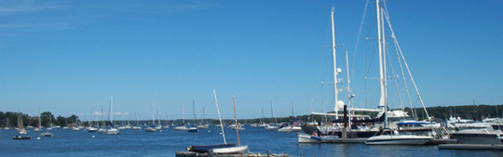

- Have your MSD inspected regularly to ensure that it is functioning properly.
- Do not dispose of fats, solvents, oils, emulsifiers, disinfectants, paints, poisons, phosphates, diapers, or other similar products in your MSD.
- Avoid discharging treated sewage in congested or poorly-flushed areas.

Gray Water

Gray water includes soaps and detergents from boat showers, dishwashing, and laundry facilities. These soaps, even those labeled as “biodegradable,” contain substances that might be harmful to marine life.

- Use shoreside showers, dishwashing stations, and laundry facilities whenever they are available.
- Check product labels and use low nitrogen and phosphorous detergents for on-board laundry, dish washing and general cleaning.
- Use all soaps and cleaners sparingly.

Adapted with permission from Connecticut Clean Marina Guide Book Connecticut Department of Environmental Protection

Clean Boater
Fact Sheet

