Boat Operation & Fueling

The way that you operate your boat or personal watercraft can have a direct effect on public safety and the environment. When not operated properly, boats can result in injuries to people and animals, and can cause pollution. Specific considerations should be given when fueling your boat. Consider the following tips to make sure your boating activities are safe and protect the environment.

Boat Operation

Soaps and solvents are toxic to marine life. Take care when using harmful products near the water.
- Observe all rules and regulations including “no wake” zones.
- Avoid operating through shallow areas (<3 feet). You risk causing damage to your boat and you may be harming sensitive habitats, such as eelgrass. If you are not familiar with the waters near the shore, proceed cautiously and refer to the most current local charts.
- Watch your wake when boating near marshes and eroded banks. Your wake could cause erosion of marsh or shoreline.
- Unless traveling to and from a port of entry or through a navigational channel, don’t regularly operate your personal watercraft within 200 feet of shore.
- Take a boating safety course. Call your local Coast Guard Auxiliary or Power Squadron.
- When your outboard motor needs replacing, consider a highly efficient 4- stroke or direct fuel injection 2-stroke engine. These higher efficiency engines will save you money on fuel and reduce the amount of unspent fuel that is released into the environment.

Fueling

- Attend to fuel hose when fueling.
- Always use an oil absorbent cloth or pad when fueling to catch small drips, particularly when you remove the fuel nozzle from the boat’s fuel line.
- Prevent spills by not topping off fuel tank, and listening to the filler pipe to anticipate when the tank is full.
- To prevent spills from the tank vent of a built-in fuel tank, install a fuel/air separator or an air whistle in your tank line, or use a vent cup to capture overspill. Ask marina staff if they know who can provide this service.
- Avoid overfilling tanks; remember that fuel expands as it warms up in the tank after being pumped from cooler storage tanks.
- Fill portable tanks on shore.
- Add a stabilizer to your fuel if you use your boat infrequently. This will help preserve the fuel and make sure it burns efficiently.

Clean Boater
Fact Sheet

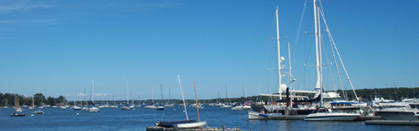

- If you see a leak or spill of any fuel, stop the spill at the source and contact the marina staff immediately.
- You must report a spill to the New York State Department of Environmental Conservation’s Spill Response Unit at 1 (800) 457-7362. If the spill causes a “sheen” on the water, it must also be reported to the National Response Center at (800) 424-8802.
- Understand that squirting any detergent or emulsifier on an oil slick is not good for the environment, against the law, and can bring heavy fines.

Adapted with permission from Connecticut Clean Marina Guide Book Connecticut Department of Environmental Protection

Clean Boater
Fact Sheet

